ASSIGNMENT REPORT
Lab Report: Assignment 5 – The HTML Web Table Extractor
Tier 2: Advanced User Interactions
Field | Details
Tier | Tier 2: Advanced User Interactions
Module | Assignment 5 – Web Table Data Extraction
Framework | Selenium WebDriver with Python
Target URL | https://testautomationpractice.blogspot.com/

1. Objectives
- Locate and parse multi-column HTML data tables programmatically.
- Iterate through table structures using dynamic XPath row (tr) and column (td) indexing.
- Implement lookup logic to locate a row by matching a name string and extract a target value from an adjacent column (e.g., Price/Status).

2. Technical Task Execution Summary
Task Requirement | Implementation Approach | Code Pattern
Row/Column Iteration | Count rows and headers dynamically | len(driver.find_elements(By.XPATH, "//table[@name='BookTable']//tr"))
Name Matching | Match string in Column 1 (BookName) | if book_name == "Learn Selenium":
Target Extraction | Fetch adjacent Column 4 (Price) cell | driver.find_element(By.XPATH, f"//tr[{r}]/td[4]").text
Verification & Proof | Highlight matched row & capture screenshot | execute_script("arguments[0].style.backgroundColor = 'lightgreen';", row)

3. Source Code & Screenshots
The automation script (assignment_5_table_extractor.py) is divided into a setup block, the row/column extraction logic, and a final screenshot step. Each screenshot is placed after the code that captures it.

3.1 Setup & Scroll to WebTable Section
import time
from selenium import webdriver
from selenium.webdriver.common.by import By

# 1. Initialize Driver
driver = webdriver.Chrome()
driver.get("https://testautomationpractice.blogspot.com/")
driver.maximize_window()
time.sleep(2)

# 2. Scroll to WebTable Section
table = driver.find_element(By.NAME, "BookTable")
driver.execute_script("arguments[0].scrollIntoView({behavior: 'smooth', block: 'center'});", table)
time.sleep(1)

# SCREENSHOT 1: Initial Web Table State
driver.save_screenshot("assignment_5_step1_table_overview.png")
print("Saved: assignment_5_step1_table_overview.png")

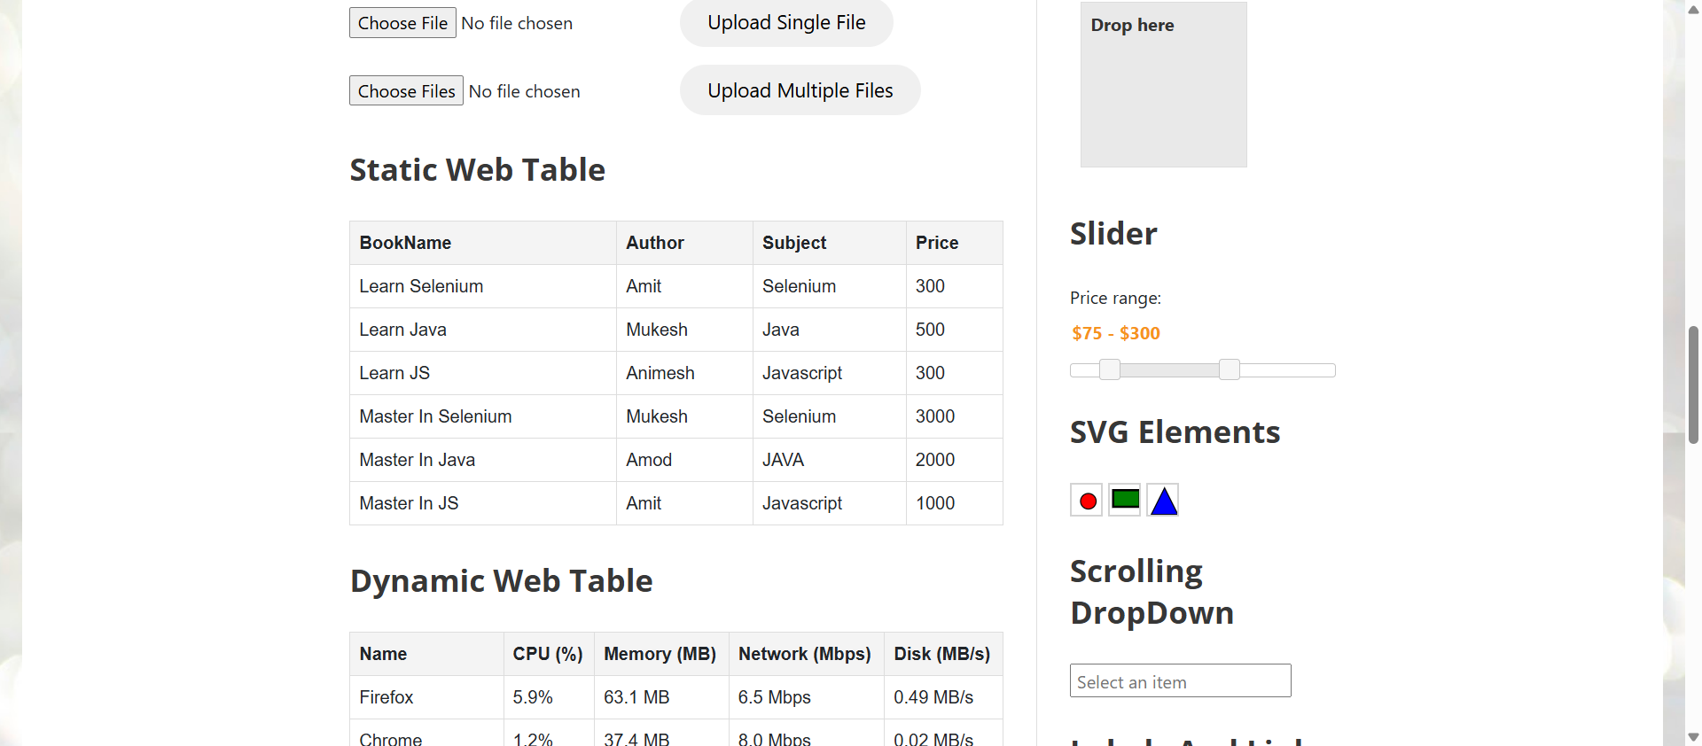
[ Insert Screenshot 1 here ]
assignment_5_step1_table_overview.png
Figure 1: Table overview prior to search execution

3.2 Web Table Row & Column Extraction
# =============================================================
# TASK STEPS: WEBTABLE ROW & COLUMN EXTRACTION
# =============================================================

# Fetch total rows and columns
rows = driver.find_elements(By.XPATH, "//table[@name='BookTable']//tr")
columns = driver.find_elements(By.XPATH, "//table[@name='BookTable']//tr[1]//th")

total_rows = len(rows)
total_cols = len(columns)

print(f"Total Rows: {total_rows} | Total Columns: {total_cols}\n")

# Target Search Parameters
target_name = "Learn Selenium" # Name string to locate in Column 1 (Book Name)
target_column_index = 4 # Column 4 corresponds to "Price"

found_price = None

# Iterate through rows starting from index 2 (skipping header row 1)
for r in range(2, total_rows + 1):
# Retrieve Book Name from Column 1
book_name_xpath = f"//table[@name='BookTable']//tr[{r}]/td[1]"
book_name = driver.find_element(By.XPATH, book_name_xpath).text

# Locate specific row matching the target name string
if book_name == target_name:
# Retrieve value from corresponding target column (Price)
price_xpath = f"//table[@name='BookTable']//tr[{r}]/td[{target_column_index}]"
found_price = driver.find_element(By.XPATH, price_xpath).text

# Highlight target row in green using JavaScript
matched_row = driver.find_element(By.XPATH, f"//table[@name='BookTable']//tr[{r}]")
driver.execute_script("arguments[0].style.backgroundColor = 'lightgreen';", matched_row)

print(f"MATCH FOUND!")
print(f"Row Name: '{book_name}' ---> Corresponding Price: {found_price}")
break

3.3 Extracted & Highlighted Result
# SCREENSHOT 2: Extracted & Highlighted Result
time.sleep(1)
driver.save_screenshot("assignment_5_step2_extracted_row.png")
print("Saved: assignment_5_step2_extracted_row.png")

driver.quit()

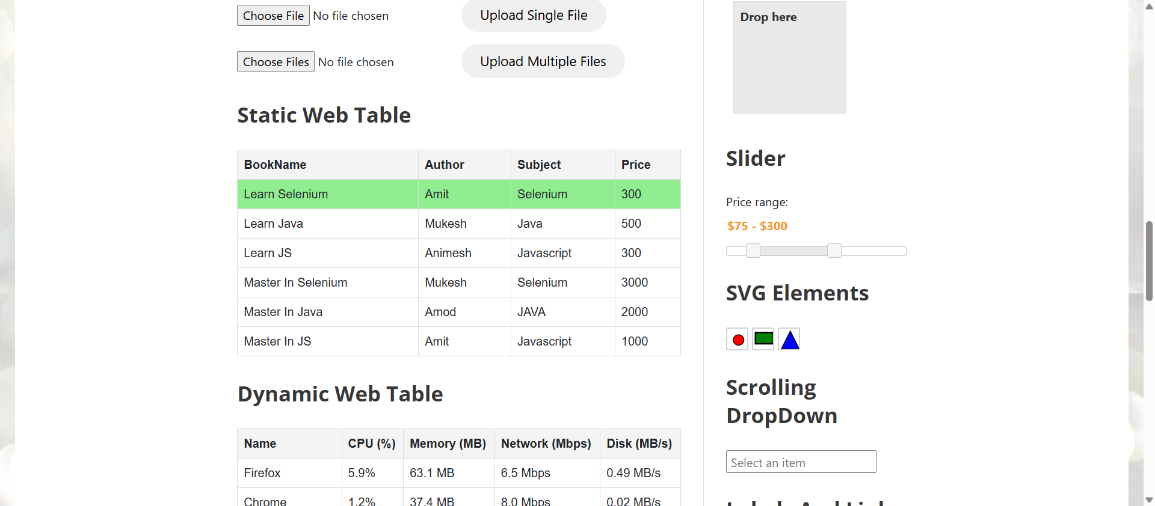
[ Insert Screenshot 2 here ]
assignment_5_step2_extracted_row.png
Figure 2: Target row highlighted in green with matched value

4. Execution & Verification Steps
- Execution: Run python assignment_5_table_extractor.py inside the active virtual environment.
Terminal Output Verification:
- Total Rows detected: 7 (1 header + 6 data rows).
- Column count detected: 4 (BookName, Author, Subject, Price).
- Located target row matching 'Learn Selenium'.
- Retrieved corresponding Price value: 300.
Screenshot Proof Output:
- assignment_5_step1_table_overview.png: Table overview prior to search execution.
- assignment_5_step2_extracted_row.png: Shows target row highlighted in green with matched value.

5. Conclusion
Assignment 5 from Tier 2 was successfully implemented. The script dynamically navigates multi-column web tables, performs row search matching, and accurately extracts corresponding data values from adjacent target columns.

